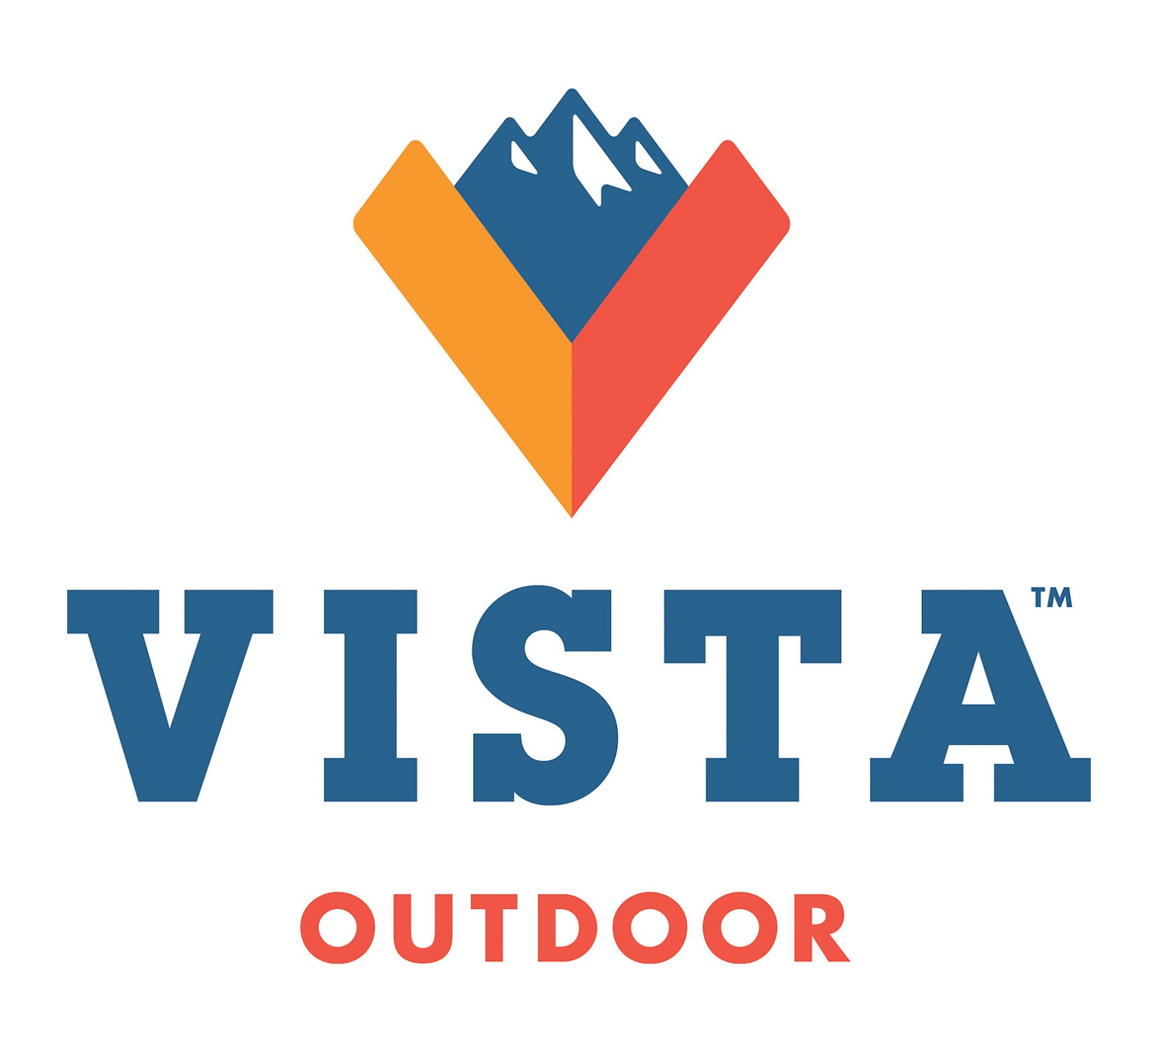
News Release | Corporate Communications  938 University Park Boulevard, Suite 200  Clearfield, UT 84015 |  | Phone: 801-779-4600
For Immediate Release
Media Contact: |  | Investor Contact:
Amanda Covington |  | Michael Pici
Phone: 801-779-4625 |  | Phone: 801-779-4614
E-mail: media.relations@vistaoutdoor.com |  | E-mail: investor.relations@vistaoutdoor.com

Vista Outdoor Selects Backbone Media as Public Relations Agency

CLEARFIELD, Utah, September 15, 2015 – Vista Outdoor Inc. (NYSE:VSTO), a global designer, manufacturer and marketer of products in the outdoor sports and recreation markets, has appointed active lifestyle agency Backbone Media as its agency of record for communications strategy and public relations outreach.

“This is an exciting period of growth for Vista Outdoor,” said Amanda Covington, Vista Outdoor’s Vice President of Communications and Government Relations. “Our mission is to bring the world outside, and we are committed to delivering great products to all manner of outdoor enthusiasts. Our partners at Backbone Media have proven experience in building deep connections between best-in-class brands and their target audiences, both broad and endemic.”

With Chairman and CEO Mark DeYoung focused on organic growth and expansion into new markets, Vista Outdoor is actively adding to an already impressive family of brands such as Bushnell®, Federal Premium®, Savage™, BLACKHAWK!®, Primos® and Bollé®. Vista Outdoor offers products in a variety of individual outdoor activities, including hunting, shooting sports, golf, skiing, hiking, paddle boarding and more.

“Vista Outdoor has a compelling mission, and the company is a bridge to all outdoor enthusiasts regardless of pursuit,” said Nate Simmons, Managing Partner at Backbone Media. “This is clearly the kind of company Backbone wants to support, and we are proud to play our role in shaping the company’s path forward.”

Since 1997, Backbone Media has worked with clients in the outdoor recreation industry to amplify active lifestyle brands and cultivate lasting connections. The Backbone team will work closely with Vista Outdoor Communication Managers J.J. Reich and Jake Edson for responsive and proactive media outreach to a range of media partners. Reich will continue to manage the Shooting Sports segment including brands such as Federal Premium, Savage, CCI®, Alliant Powder® and Speer®. Edson will oversee communications for Vista Outdoor accessories brands, including Bushnell, BLACKHAWK!, Primos, Gold Tip®, Hoppe’s®, Bollé, RCBS®, Champion®, and many other market-leading brands.

PR CONTACTS
J.J. Reich
Vista Outdoor Communications Manager-Shooting Sports
(763) 323-3862
E-mail: vistapressroom@vistaoutdoor.com

Jake Edson
Vista Outdoor Communications Manager-Outdoor Products
(763) 323-3865
E-mail: vistapressroom@vistaoutdoor.com

Tyler Pearce
PR Account Manager
Tyler.Pearce@backbonemedia.net
(970) 963-4873 ext. 120

Gavin Robinson
PR Account Manager
Gavin.Robinson@backbonemedia.net
(970) 963-4873 ext. 154

About Vista Outdoor Inc.
Vista Outdoor is a leading global designer, manufacturer and marketer in the growing outdoor sports and recreation markets. The company operates in two segments, Shooting Sports and Outdoor Products, and has a portfolio of well-recognized brands that provide consumers with a range of performance-driven, high-quality and innovative products in the ammunition, firearms and outdoor products categories. Vista Outdoor products are sold at leading retailers and distributors across North America and worldwide. Vista Outdoor is headquartered in Utah and has manufacturing operations and facilities in 10 U.S. States, Puerto Rico, Mexico and Canada along with international sales and sourcing operations in Canada, Europe, Australia, New Zealand and Asia. For news and information, visit www.vistaoutdoor.com or follow us on Twitter @VistaOutdoorInc and Facebook atwww.facebook.com/vistaoutdoor.

###

